Gastrostomy Tube (G-tube) Care at Home

It is important to take good care of your new g-tube to help prevent infection around the insertion site and to minimize complications while using the tube.

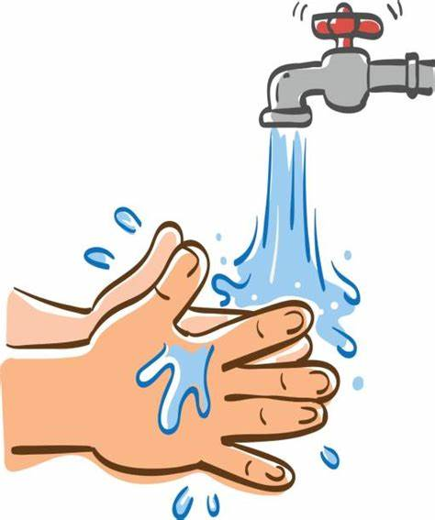
Daily Site Care:
- Wash your hands before and after caring for your g-tube.
- Check the skin around the tube site for redness, a rash, swelling, drainage, or extra tissue growth.
- Wash skin around the insertion site with warm and soapy water, making sure to remove any dried drainage.
- Rinse and pat dry.
- A small, thin split gauze or fabric dressing may be used around the site if it is leaking.
- Do not use any creams or lotions around the site unless otherwise directed.
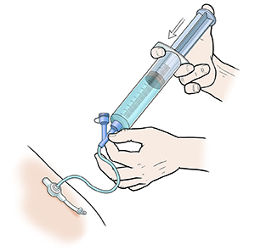
Using your g-tube:
- Flush your child’s g-tube with water
  - Before and after feeds and medication.
  - Flush with enough water to clear the extension tubing.

- Giving medications
  - Flush tube before giving any medications.
  - Give liquid medications directly into the medication port.
  - For pills and capsules, check with your pharmacist before giving through the g-tube.
  - After giving medications flush with enough water to clear the extension tubing.
  - If giving more than 1 medication, flush with water after each medicine.
  - Disconnect extension tubing when done and close the safety cap.

- Giving a feed
  - Flush tube before giving any feed.
  - Your child will have either bolus feeds, continuous feeds, or both.
  - Give feed as directed by your doctor.
  - After the feed is completed, flush with enough water to clear the extension tubing.
  - Disconnect extension tubing when done and close the safety cap.

- Venting the tube
  - Venting may be needed to remove extra air or fluid from your child’s stomach.
  - Your child’s care team will tell you if this is needed.
  - A large syringe or a special feeding bag can be used for venting.

How to Deal With Common Problems
If problems occur with your child’s new g-tube, use the chart below to review and care for the g-tube. If the problem is not listed or if you need additional help, please contact our clinic.
Problem |  | Solution
Redness or irritation around the site | 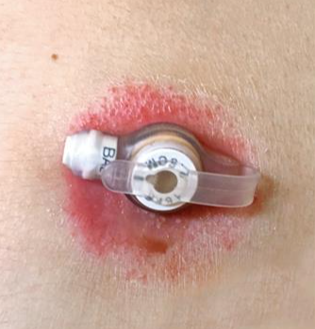 | If using a dressing around the g-tube, make sure to keep it clean and dry.  Change the dressing when dirty and continue routine skin care.  A skin barrier cream may be recommended at this time.  Please call our clinic for further instructions.
Leaking at site |  | A small amount of leaking is normal. Leaking may increase with crying, constipation, or teething.  Large amounts of leaking are not normal.  Look for the cause of the leak.  Is the cap open? Is the size correct?  For gtubes older than 8 weeks check the amount of water in the balloon.  If you have questions or concerns about leaking please call our clinic.
Excess tissue at the site | 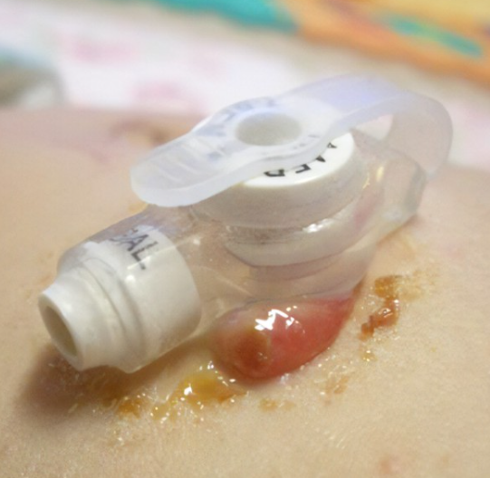 | This is called granulation tissue. It is normal for this tissue to bleed and have a yellow/brown drainage.  This is not an emergency but does need to be treated in a timely manner.  Keep the site clean and dry. Secure the g-tube with tic-tac-toe tape.  Call our clinic to discuss treatment options.
G-tube is clogged and not working |  | Slowly try to push and pull warm water using a 30ml or larger syringe. DO NOT try to use any object to unclog it. If the tube cannot be unclogged, it will need to be replaced.
G-tube was pulled out | 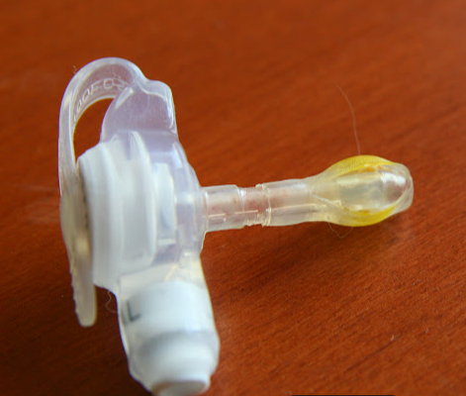 | If it has been less than 8 weeks since surgery, do not re-insert the tube. Cover the site with gauze and tape. Bring the g-tube with you and return to the ER to have the tube replaced.  If it has been more than 8 weeks since surgery, you may reinsert the tube if you have been properly trained.
For any questions or concerns, please call our clinic at 210-743-2500 Monday-Friday 8AM-4:30PM
or send an e-mail to pediatricsurgeryclinic@uhs-sa.com

